**Project Planning Phase**

**Project Planning Template (Product Backlog, Sprint Planning, Stories, Storypoints)**

|  |  |
| --- | --- |
| Date | 18October 2022 |
| Team ID | PNT2022TMID49326 |
| Project Name | Project - Fertilizers Recommendation System For Disease Prediction |
| Maximum Marks | 8 Marks |

**Product Backlog, Sprint Schedule, and Estimation (4 Marks)**

Use the below template to create product backlog and sprint schedule

| **Sprint** | **Functional Requirement (Epic)** | | **User Story Number** | **User Story / Task** | **Story Points** | **Priority** | | | **Team Members** |
| --- | --- | --- | --- | --- | --- | --- | --- | --- | --- |
| Sprint-1 | Model Creation  and Training  (Fruits) | |  | Create a model which can classify diseased fruit plants from given images. I also need to test the model and deploy it on IBM Cloud | 8 | High | | | Karthika S, Sabeena V, Tamil elakkiya M, Karthika K, Deeparani L |
|  | Model Creation  and Training  (Vegetables) | |  | Create a model which can classify diseased  vegetable plants from given images | 2 | High | | | Karthika S, Sabeena V, Tamil elakkiya M, Karthika K, Deeparani L |
| Sprint-2 | Model Creation  and Training  (Vegetables) | |  | Create a model which can classify diseased  vegetable plants from given images and train on IBM Cloud | 6 | High | | | Karthika S, Sabeena V, Tamil elakkiya M, Karthika K, Deeparani L |
|  | Registration | | USN-1 | As a user, I can register by entering my email,  password, and confirming my password or via  OAuth API | 3 | Medium | | | Karthika S, Sabeena V, Tamil elakkiya M, Karthika K, Deeparani L |
|  | Upload page | | USN-2 | As a user, I will be redirected to a page where I can upload my pictures of crops | 4 | High | | | Karthika S, Sabeena V, Tamil elakkiya M, Karthika K, Deeparani L |
|  | Suggestion result | | USN-3 | As a user, I can view the results and then obtain the suggestions provided by the ML model | 4 | High | | | Karthika S, Sabeena V, Tamil elakkiya M, Karthika K, Deeparani L |
|  | Base Flask App | |  | A base Flask web app must be created as an  interface for the ML model | 2 | High | | | Karthika S, Sabeena V, Tamil elakkiya M, Karthika K, Deeparani L |
| Sprint-3 | Login | | USN-4 | As a user/admin/shopkeeper, I can log into the  application by entering email & password | 2 | High | | | Karthika S, Sabeena V, Tamil elakkiya M, Karthika K, Deeparani L |
|  | User Dashboard | USN-5 | | As a user, I can view the previous results and  history | 3 | Medium | | Karthika S, Sabeena V, Tamil elakkiya M, Karthika K, Deeparani L | |
|  | Integration |  | | Integrate Flask, CNN model with Cloudant DE | 5 | Medium | Karthika S, Sabeena V, Tamil elakkiya M, Karthika K, Deeparani L | | |
|  | Containerization |  | | Containerize Flask app using Docker | 2 | Low | Karthika S, Sabeena V, Tamil elakkiya M, Karthika K, Deeparani L | | |
| Sprint-4 | Dashboard  (Admin) | USN-6 | | As an admin, I can view other user details and  uploads for other purposes | 2 | Medium | Karthika S, Sabeena V, Tamil elakkiya M, Karthika K, Deeparani L | | |
|  | Dashboard  (Shopkeeper) | USN-7 | | As a shopkeeper, I can enter fertilizer products and then update the details if any | 2 | Low | Karthika S, Sabeena V, Tamil elakkiya M, Karthika K, Deeparani L | | |
|  | Containerization |  | | Create and deploy Helm charts using Docker  Image made before | 2 | Low | Karthika S, Sabeena V, Tamil elakkiya M, Karthika K, Deeparani L | | |

| **Sprint** | | **Total Story Points** | | **Duration** | **Sprint Start Date** | | **Sprint End Date (Planned)** | | **Story Points Completed (as on Planned End Date)** | | **Sprint Release Date (Actual)** | |
| --- | --- | --- | --- | --- | --- | --- | --- | --- | --- | --- | --- | --- |
| Sprint-1 | | 10 | | 6 Days | 24 Oct 2022 | | 29 Oct 2022 | | 10 | | 30 Oct 2022 | |
| Sprint-2 | | 15 | | 6 Days | 31 Oct 2022 | | 05 Nov 2022 | | 15 | | 06 Nov 2022 | |
| Sprint-3 | | 15 | | 6 Days | 07 Nov 2022 | | 12 Nov 2022 | | 15 | | 13 Nov 2022 | |
| Sprint-4 | | 12 | | 6 Days | 14 Nov 2022 | | 19 Nov 2022 | | 10 | | 20 Nov 2022 | |
|  |  | |  | | |  | |  | |  | |
|  | |  | |  |  | |  | |  | |  | |
|  | |  | |  |  | |  | |  | |  | |
|  | |  | |  |  | |  | |  | |  | |

**Project Tracker, Velocity & Burndown Chart: (4 Marks)**

***NOTE: Burndown charts, Velocity to be updated dynamically after end of sprints***

**Roadmap:**

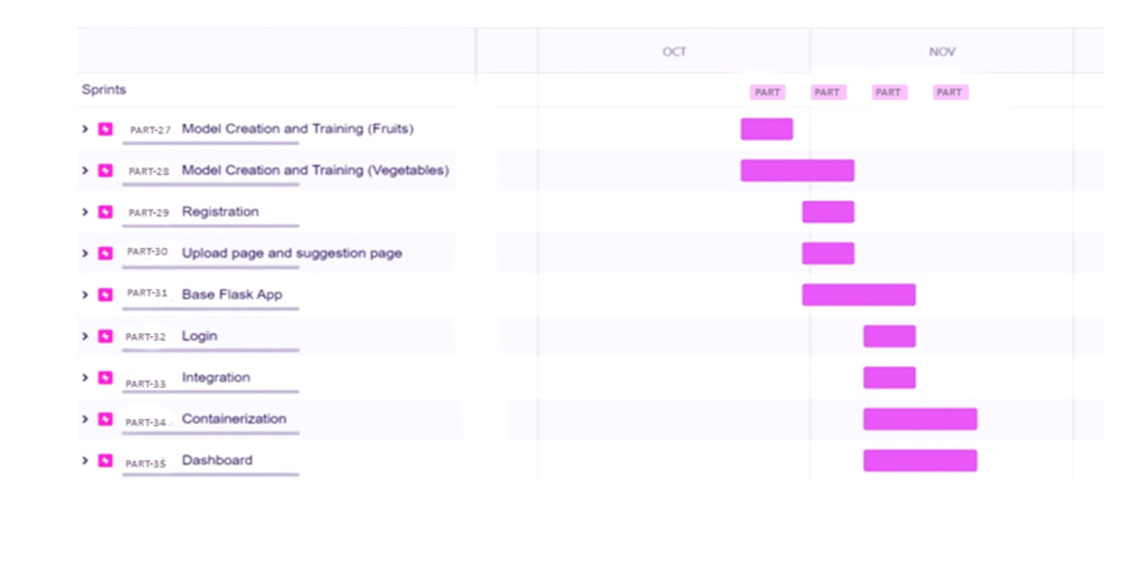

**Screenshots:**